INTRODUCTION

Mark Thurner and Juan Pimentel

Unlike Neil MacGregor’s bestselling *History of the World in 100 Objects*, our small cabinet’s curious objects cannot be found in a single museum. The reasons for this are several. First, from the late fifteenth century down to our own day, the New World and in particular that part of it now called Latin America, has been plundered and pilfered for its ‘treasures’ and ‘wonders’ not by one conqueror, empire, explorer, collector, or museum, but by many. Consequently, many of its natural and cultural productions are scattered around the world, and in too many cases the provenance of the object has been lost. Second, the global nature of knowledge production has, since the sixteenth century, meant that everywhere objects have been removed not once but several times to new sites of study, storage and display. As a result, many key objects of modern wonder and knowledge have had several owners and keepers, indeed several ‘afterlives.’ Their histories and identities have often been lost, or remade, in the shuffle.

Our small cabinet of curiosities of New World objects of knowledge is thus not a select inventory of any museum collection. It is instead the collective product of the LAGLOBAL international research network. It responds to the LAGLOBAL (acronym for ‘Latin America and the Global History of Knowledge’) charge to make accessible to the non-specialist reader knowledge otherwise difficult to access. With generous support from the Leverhulme Trust and, at turns, the network’s several institutional partners (Institute of Latin American Studies, University of London; Centre Amerindian, Latin American and Caribbean Studies, Saint Andrews; Department of the History of Science, CSIC, Madrid; Department of the History of Medicine and Science, FIOCRUZ, Rio de Janeiro; Department of Anthropology, History and the Humanities, FLACSO-Ecuador, Quito; Department of Historical Studies, El Colegio de Mexico; Institute of Historical Studies, University of Texas at Austin; the John Carter Brown Library, Brown University), our purpose at LAGLOBAL is to advance and disseminate research on Latin America’s frequently neglected and often invisible contributions to the global history of knowledge.

This portable cabinet squeezed between two covers is not an encyclopedia. It consists of about forty, finely illustrated, eye-opening entries of 1000-4000 words that, each in its own way, attempts to capture the dynamic, often global itineraries of key New World objects of knowledge. Our object-images range from Pre-Columbian codices to colonial portrait paintings, and from enlightenment treatises to medicine cabinets, volcanoes, and fossil bones. Any New World cabinet could house hundreds of objects or images, but our aim here is not to be comprehensive nor systematic. Like most historical cabinets, ours reflects the interests and contingencies of its collectors and keepers. In this sense, it is clearly the contingent product of the recent itinerary of the LAGLOBAL project. That itinerary includes a series of international workshops held in the museums, libraries and research centres of London, Madrid, Seville, Cadiz, Rio de Janeiro, and Quito.

Our purpose here is not to prescribe how to read these objects but instead to gently encourage historical curiosity in the reader with an eye for images and objects. In this regard, our little cabinet is not so unlike those early modern *Gabinete* (Spanish), *Studiolo* (Italian) or *Wunderkammer* (German). Indeed, we have thus modestly opted to mimic the traditional classificatory structure of early modern cabinets, dividing our objects into the questionable but historically significant categories of *Artificialia* and *Naturalia*. We do this with clear recognition that the ‘natural’ things in our cabinet are ‘artificial’ representations with specific histories.

Our further aim here is to incite critical curiosity about the New World as a key protaganist in the history of modern knowledge. A prime example of this curious but at the same time critical mix of the artificial and the natural, condensed in an object of New World knowledge, is the stunning *Quadro del Perú* (1799). This Hispano-Italo-Peruvian ‘wall museum’ or ‘painted museum’ is a veritable cabinet in itself. Like a museum, it embraces in a single work several genres or discourses of representation and transmission, including scientific and historical text, landscape, miniature portraiture, and cartography, all in a framed exhibition that presents hundreds of niches or galleries of Peruvian naturalia and artificialia. It will serve us well in this introduction as a potent illustration of our purpose and method.

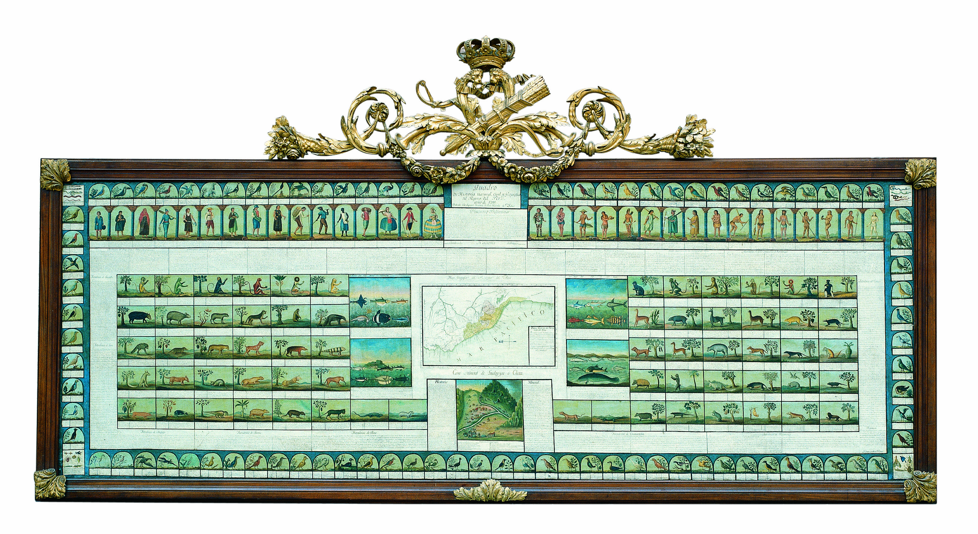Figure 1. *Quadro de Historia Natural, Civil y Geográfica del Reyno del Perú, año de 1799*. Courtesy of the National Museum of Natural Sciences, Madrid. A high quality image of the *Quadro* is available for viewing on the Google Arts and Culture platform: <https://artsandculture.google.com/asset/quadro-de-historia-natural-civil-y-geogr%C3%A1fica-del-reyno-del-per%C3%BA-jos%C3%A9-ignacio-de-lequanda/igE86USP5Q1cYg?hl=es>

There have been and are many ways to interact with this object. It’s perhaps easy to imagine all the people and animals depicted in *El Quadro del Perú* leaping out of their colourful frames and into our post-Google world of virtual galleries and video messages, in a sort of animated Trompe-l'œil. But can we imagine the reverse? If, like Alice in Wonderland, we could swallow a shrinking pill, step through the looking-glass, and find ourselves in the underworld of *El Quadro*, what might we see and learn?

Despite the lacunae of the historical record, scholars have pieced together key elements and moments in the secret career of the *Quadro del Perú*. From its intercultural gestation in late eighteenth-century Peru to its purgatory in Madrid’s colonial and museal offices and its more recent mass exposure on the Google Arts & Culture web platform, the Quadro has been a silent witness to a chiaroscuro history of enlightenment and ignorance. On the one hand, the Quadro is a brilliant tableau of the natural and cultural ‘treasures’ of Peru, a jewel in the crown of the ‘Spanish Enlightenment,’ as its gilded frame unmistakably announces. On the other hand, this enlightened tableau of Peruviana is a spectre, a ghost, a haunting sign of loss and ignorance. First, properly understood, it represents the knowledge production not of the ‘Spanish Enlightenment’ as it is often read in Spain, but of the global and colonial Peruvian Enlightenment. Second, for most of its history it has gone largely unseen, in part due to bureaucratic contingencies, and in part because the Quadro fits uneasily into dominant modes of aesthetic, scientific, and museal classification. As an unseen, unsung and uncomfortable artefact of colonial enlightenment, the Quadro is a potent emblem for the LAGLOBAL project and an appropriate starting point for this New World cabinet of curiosities. As it turns out, the LAGLOBAL project and the Quadro share common goals. European ignorance of Peru was one of the primary motives behind the production and framing of the Quadro. Similarly, LAGLOBAL is devoted to recovering the lost knowledge of the Iberian New World or ‘Latin America’ for the global history of knowledge, where it is too often ignored.

The primary intellectual author of the Quadro perished in the port of Cadiz in 1800 before he could disembark for his adopted home in Peru. Most likely a victim of smallpox, he had only just completed and delivered the Quadro to the Secretariat of the Indies in Madrid. Born in Vizcaya, José Ignacio de Lecuanda (1748-1800) had spent most of his productive life in Lima. There he played an important part in the collective academic project of the *Sociedad Académica de Amantes de Lima* (Academic Society of Patriots of Lima), whose most famous print legacy was the brilliant scientific, historical and literary journal, the *Mercurio Peruano* (1791-94). As historian Victor Peralta has argued, the Quadro is an illustrated encapsulation of the spirit and letter of the Lima Academic Society’s learned project and journal. The society included savants born not only in Peru but also in other parts of the vast Hispanic realm, including Italy and the Iberian Peninsula. From the very first issue, the *Mercurio Peruano* had explicitly sought not only to enlighten Peruvian readers with scientific reports and historical essays about ‘the country.’ It also sought to combat European ignorance about Peru’s place ‘in the universe’ of science and letters, where it faired rather badly. Most European savants considered Peru to be a ‘semi-barbarous’ land of downtrodden peoples ruled by ignorant despots and inquisitors, and thus void of enlightenment.

The many illustrations that together compose the dazzling Quadro, drawn by Louis Thiebaut in Madrid from an archive of drawings and prints, paints Peru’s place in the universe as one of unparalleled abundance, and useful knowledge of that abundance. The Quadro drew upon Peruvian concepts, sources and earlier illustrations, including the so-called Trujillo Codex (1782-85) assembled by native and mestizo informants, collectors and artists working under the direction of the Bishop of Trujillo, Martínez Compañón, who in turn was responding to an official call to assemble objects of knowledge about Peru and submit them to Madrid and its Royal Natural History Cabinet, directed and founded by the Peruvian Creole Pedro Franco Davila (see Creole Cabinet in this volume). Other images found in the Quadro were derived from the Malaspina Expedition, one among the many notable global scientific projects associated with the Hispanic Enlightenment. In turn, that expedition had derived many if not most of its findings from Peruvian sources. In effect, the Quadro mixes its iconographic motifs from several genres, including Casta painting (portraits of mixed-race couples) and the *mapas orlados* or *cartes à figures*, those ornate early modern maps in the Flemish tradition, in which representative human figures of the territory populate the borders of the map.

What kind of artefact is the Quadro? The answer is not simple. Is it art? Is it science? Is it a painting? A book? A map? A gallery? A portable cabinet? A wall museum? Where does it belong? The Quadro is all these things, but it does not quite fit fully or comfortably into any one of them. The material of the Quadro is oil on canvas, which suggests it is a painting. It is distinguished however by its dimensions (331 cm x 118 cm) and composition: 195 scenes with 381 figures accompanied by an extensive explanatory text interspersed in the scenes, maps and landscapes. In addition, the framed canvas is crowned and gilded with twin cornucopias graced by a sheaf of arrows, symbolizing the bounty of the New World or America under Hispanic Monarchy. The two central geographical images (an east-up map of Central Peru, below which is a profile view of the rich new mines at Hualgayoc) form an axis that represents the new economic fulcrum point of eighteenth-century Peru, which had shifted from the southern mining region around Potosi to the central region adjacent to Lima. Notably, the central region encompassed coastal Lima and new highland mines as well as the relatively undeveloped but highly promising Amazonian region to the east, thus uniting three major ecological and productive zones within a relatively short distance. In the Quadro, this vertical economic geography is represented by the unfolding of a concentric sequence of cells and niches populated by fishes and amphibians, small and large quadrupeds, simians and humans, the latter divided in two classes, ‘civilized’ (or coastal and highland) and ‘savage’ (or Amazonian), with each composed of sixteen ‘nations’ or ethnic groups. Birds occupy the perimeter of the Quadro, seemingly lifting the entire canvas on their wings. The four corners are notably reserved for reptiles and insects, beings that, to be sure, had always occupied disquieting positions in the Great Chain of Being. Nevertheless, the Quadro is clearly not merely another iteration of the *scala naturae*, a Neoplatonist scheme that in the eighteenth century was twisted to serve racialist and supremacist thought in Europe. That twisting scheme had been energetically rejected in Peru by José Hipólito Unanue, an influential member of the Academic Society of Patriots of Lima. In its stead, Unanue offered an alternative vision of Peru as a land of unparalleled natural and cultural diversity that, in most ways, was more universal than Europe (see ‘Andes’ entry in this volume).

The Quadro is a mimetic device that reveals in synoptic visual fashion what today would be called ‘biodiversity’ and ‘cultural diversity’ but which in Peru at the time was simply called ‘the idea of Peru.’ This ‘idea’ was a well-developed notion evident in historiography, natural science, and iconography. The idea was that Peru was culturally and naturally sovereign. Favoured by providence, geography and history, Peru lacked nothing. With its astounding vertical climatic diversity, Unanue and other *Mercurio Peruano* authors argued that Peru was the teaming home of more fauna and flora than anywhere else on the planet. This diversity could be put to productive use, transforming Peru into a prosperous cornucopia for the world. This desire to convey the exuberant nature of Peru is expressed in the irrepressible dispersion of text within the Quadro itself, which snakes through the Eden of Peruvian biodiversity depicted in the painted frames. Lequando is the author of this snaking encyclopedia, whose title is the name given to the Quadro as a whole: *Quadro de Historia Natural, Civil y Geográfica del Reyno del Perú, año de 1799*. His profuse text draws upon previous writings by the author, including learned essays published in the *Mercurio Peruano* and statistical reports on Peruvian political economy, prepared for Peru’s Viceroy and, later, submitted to the Secretariat of the Indies in Madrid along with the Quadro itself.

The teaming, cornucopian Quadro was in fact an emphatic argument, a polemical point of view, in ongoing debates about the ‘genius’ and nature of the New World, and about the status of the Hispanic American kingdoms ‘in the universe.’ At the time, many European savants held that in the New World, and particularly in the American tropics, nature was relatively young, humid, and weak; the effects of this nature on people and civilization were enfeebling or degenerative. Such ‘enlightened’ views had been preceded by the ancient Aristotelian and Ptolemaic traditions, in which the ‘Torrid Zone’ was taken to be barren of life if not uninhabitable. In addition, by the late eighteenth century many European philosophes had argued that Peru was not a kingdom at all but a mere ‘colony,’ unfit for self-rule, in part because, in their view, the effects of Peru’s enfeebling clime were augmented by the cruel exploitation of ignorant and despotic Spain. The enlightened Peruvian authors of the *Mercurio Peruano* energetically rejected such ignorant views, arguing that Peru’s history and natural resources demonstrated that she was in fact a sovereign, self-sufficient ‘country’ that had produced her own ‘genius.’ In this way, the Quadro was a powerful visual argument against condescending, northern European views of the tropical and subtropical New World. It directly countered European myths about the supposed ignorance and backwardness both of Hispanic Empire and of Peru.

At first glance, the Quadro appears to fall midway between an inventory and a collection or gallery of images, that is, somewhere between an Andean *quipu* (a mnemonic and narrative device of colour-coded, knotted cords; see ‘Quipu’ in this volume) and *Instagram*. Like the former, it serves as an instrument for registering events and data; like the latter, it is a frame for displaying and sharing images. Lequanda was in fact an enlightened accountant, not so unlike those Inca administrators, called *quipucamayoc*, who recorded in systematic fashion and in knotted, colourful strands the fruits and rents of Tawantinsuyu, the Quechua name for the Inca Realm. The cadastral element of the Quadro aligns it not only with the quipu but indeed with the rich semantic field of the old Spanish noun that names it. According to the Real Academia Española, ‘cuadro,’ which in the 18th century was typically written ‘quadro,’ carries more than a dozen accepted meanings. Among these, the following six glosses are particularly relevant here: ‘pictorial composition on canvas, wood, paper, etc., normally framed; frame; in gardens, that part regularly cultivated in squares and adorned with flowers and herbs; description, written or oral, of a spectacle or event, so alive and animated that the reader or listener may represent in his imagination the thing being described; set of names, statistics or other data presented graphically, such that the relations among them are made evident; spectacle of nature, or group of persons or things, that offers itself to viewing and is capable of moving or terrifying the subject.’ Most of these senses of the word were anticipated in the frugal 1737 edition of the Royal Academy’s Dictionary, known as the *Diccionario de Autoridades*, where ‘Quadro’ is given eight meanings.

In short, ‘Quadro’ is an ingenious, polysemic name that captures the multidimensional nature of our artefact. Indeed, ‘Quadro’ would not be a bad title for this book if it were not for the fact that the term has fallen out of use. ‘Quadro’ thus comes close to, for English readers, the better-known French notion of *tableau*. For Foucault, the *tableau* is a device for ordering and classifying the world, a way of visualizing it and making it apprehensible. We are reminded of the great works of Turgot or Condorcet, where *tableau* alludes to compendium or synopsis; of Alexander von Humboldt’s Tableau Physique *des Andes et Pays Voisins* or indeed of his famous vertical profile or *Naturgemaelde* of Chimborazo (see ‘Andes’ in this volume) in the *Geographie des Plantes*.

Why was the Quadro presented in Madrid? And how did it end up hanging, as it does today, on an office wall in Madrid’s Natural Museum of Natural Sciences, out of public view? In a sense, the Quadro was for Lequanda personally and the Peruvian Enlightenment collectively (although as we shall see this was problematic), a stunning calling card, a treasure of art and nature presented to the *Secretaría de Hacienda de Indias* in Madrid, as visual proof of Peru’s natural resources and political economy. Lequanda had left Lima for Madrid with a purpose. That purpose was to gain official appointment as the *Contador del Reino del Perú* (Accountant of the Kingdom of Peru), a lucrative and prestigious position that he fully deserved but was denied in Peru by the sitting Viceroy, who had favoured his rival. This effort to gain appointment from the top required the deft use of connections and knowledge. Lequanda thus participated in several notable publication projects in Madrid that, in effect, disseminated or excerpted, often without proper citation, the writings and insights of the Academic Society of Patriots of Lima. The Quadro would be the more visible trace of his efforts, though eventually it too would become nearly invisible. For, like many well-guarded and/or misapprehended treasures, access to the work has always been problematic. In its afterlife, the Quadro would become –and indeed it remains so today-- a haunting spectre of the Hispanic American enlightenment. It is precisely for this reason that the Quadro fits so well as the frontispiece and starting point of this book or ‘cabinet,’ and as an emblem for the LAGLOBAL project as a whole.

We know that the Quadro was the property of the Secretaría de Hacienda de Indias from 1799 to 1836, when the Secretariat was absorbed by the *Ministerio de Hacienda* (Ministry of the Treasury). The Quadro did not physically move premises until 1880, however, since the Ministry occupied the same building as the old Secretariat. The Ministry was located adjacent to the Goyeneche Palace on the Calle Alcala. That palace housed, under one roof, the Royal Cabinet of Natural History and the Fine Arts Academy of San Fernando. The Quadro was thus a silent witness for eight decades of the affairs of imperial officialdom, but at least it had admiring, if not jealous, neighbours. If the figures in the Quadro could step out of their niches and speak to us today, we might learn many state secrets otherwise lost to history. So many flies on the wall.

In 1880 the naturalist and historian Jiménez de la Espada petitioned the Ministry to transfer the Quadro to the Museum of Natural History, successor to the Royal Cabinet of Natural History, located next door. ‘Here,’ the petition read wishfully, the Quadro ‘may be displayed to the public under favourable conditions, such that it may be utilized for the benefit of science.’ The Ministry acceded to the request and, without crossing the street, the Quadro passed to the museum. But that was not the end of it. The expansive Ministry had its eye on the museum’s space, and soon annexed it. It was now necessary to dislodge the Quadro once again. This time, the Quadro’s fate was worse. After 1895 it became, together with much of the Natural History Museum’s collection, a homeless wanderer, making its way from the Calle Alcala to the storehouses of what is today the National Library, while many of the Quadro’s ethnological companion specimens ended up in Doctor Velasco’s Museum (an Anatomy Theatre devoted to physical anthropology), later the National Museum of Anthropology. In 1910 the Quadro found a new home at the National Museum of Natural Sciences which took up quarters in the Palace of Arts and Industries on the north side of Madrid, where both reside today. The Quadro would, once again, remain for the most part unseen by the public. But along the way it would garner the attention of one or two notable scholars and naturalists, including Francisco de las Barras de Aragón and Ignacio Bolívar. In the banner exhibition year of 1929 (the same year in which the Ibero-American Exposition opened in Seville and Barcelona) the Quadro made its appearance in a retrospective exhibit on natural history staged at the Royal Botanical Garden next to the Prado Museum. In 2005, the Quadro was finally declared by the state to be *Bien de Interés Cultural* (Object of Cultural Interest) which permitted its restoration by the Spanish Institute of Cultural Patrimony. Since then it has been the object of several notable research projects led by the Spanish Scientific Research Council (CSIC). Nevertheless, the Quadro is not normally on exhibit to the public (although it has been shown at several temporary exhibits in Madrid), according to the MNCN for preservation reasons. It hangs today on a poorly lit office wall behind the desk of the museum director’s secretary. This is where the LAGLOBAL research team examined the Quadro during a workshop held in the museum in April 2017 (Figure 2).

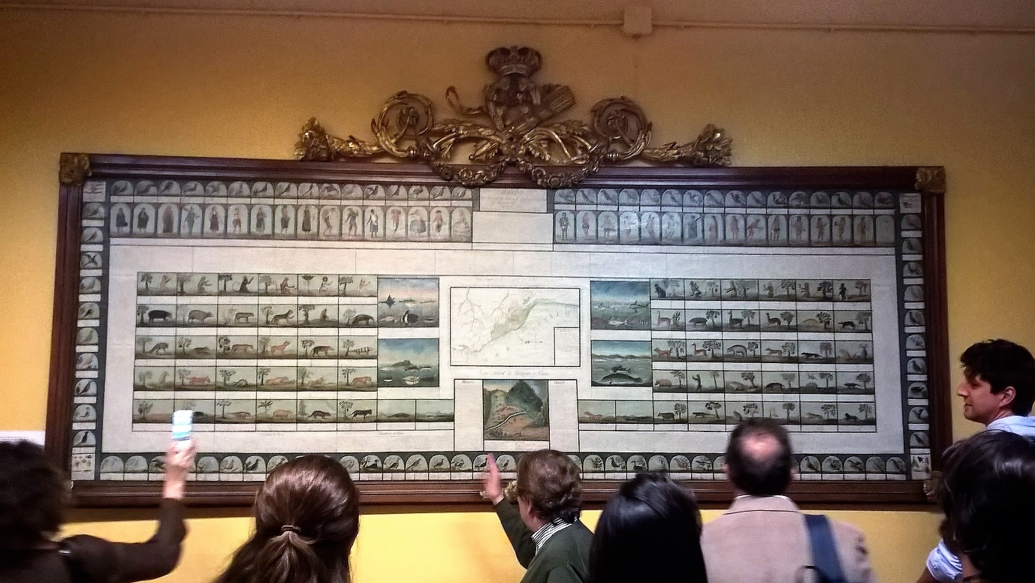

Figure 2. LAGLOBAL research team examines *El Quadro del Perú* in the offices of the National Museum of Natural Sciences, Madrid. Photograph by Mark Thurner (April 2017).

Why is the magnificent Quadro still out of public view? The full answer to our query goes beyond questions of bureaucratic rivalry, lack of funding, or preservation concerns. As we have suggested, the Quadro is true to its polysemic name; it is a mimetic and moving tableau of image, text, and map that together invite the viewer to imagine and know, if not take possession of, a world named Peru. It fits uneasily into the categories of ‘art’ or ‘science’ as these concepts are understood today. The Quadro has not made its way into the Prado Museum, where both colonial American art and science have been effectively banned from the canons of the nation and art history. Ironically, the Quadro would have fit perfectly in the original Prado that never was. The Prado was never intended to be an art museum. It was designed by Juan de Villanueva for the enlightened monarch Charles III to house the Royal Cabinet of Natural History and a Spanish Academy of Science, thus complementing the Royal Botanical Garden next door. Today, the Quadro hangs uncomfortably and out of view in the National Museum of Natural Sciences, not only for preservation reasons but because it is not true ‘science’ by contemporary Spanish standards. The Quadro’s digital afterlife on Google Arts & Culture is more heavenly than its extended museum purgatory. Removed from its materiality, history and institutional frames, the Quadro may now be examined and dissected piecemeal on any screen as ‘art’ and ‘culture.’ But the Quadro is also somewhat out-of-place here as well since it is clearly not a ‘masterpiece’ by the standards of art history.

As the frontispiece of this cabinet-book, the Quadro serves as a telling, polysemic trace of the history of knowledge and aesthetics. Each object or set of objects presented and discussed in this volume by participating scholars of the LAGLOBAL project similarly serves as a telling trace of a history of knowledge and ignorance vis-à-vis the Iberian New World. It is by no means an exhaustive collection. All cabinets are subjective and dynamic affairs that reflect moments in the lives and interests not only of the collectors but of the wider networks within which they operate. By the same token, we welcome all ‘visitors’ to this cabinet to encounter these curious objects on their own terms. Like Alice in Wonderland, we trust readers will exercise their own experience and imagination in the face of what they find here.

Further Reading

<https://artsandculture.google.com/asset/quadro-de-historia-natural-civil-y-geogr%C3%A1fica-del-reyno-del-per%C3%BA-jos%C3%A9-ignacio-de-lequanda/igE86USP5Q1cYg?hl=es>

Barras de Aragón, Francisco, ‘Una historia del Perú contenida en un cuadro al óleo de 1799’, *Boletín de la Real Sociedad Española de Historia Natural* 11 (1912), 224-285.

Bleichmar, Daniela, ‘Seeing Peruvian Nature, Up Close and From Afar’, *Res 59/69* (2011) 82-95.

Peralta, Victor, ‘La exportación de la Ilustración Peruana. De Alejandro Malaspina a José Ignacio de Lecanda, 1794-1799,’ *Colonial Latin American Review* 24:1 (2015), 36-59.

Pimentel, Juan, *Testigos del Mundo. Ciencia, literatura y viajes en la Ilustración*, (Madrid: Marcial Pons, 2003).

Pino, Fermín del, ed., *El Quadro de historia del Perú (1799), un texto ilustrado del Museo Nacional de Ciencias Naturales* (Lima: Universidad Nacional Agraria La Molina, 2014).

Sánchez-Valero, Miguel Villena, et. al., *El gabinete perdido. Pedro Franco Dávila y la historia natural del Siglo de las Luces*, (Madrid: CSIC, 2009).

Thurner, Mark, *History’s Peru: The Poetics of Colonial and Postcolonial Historiography*, (Gainesville: University Press of Florida, 2011).

Thurner, Mark, ‘Historia secreta de la ilustración. O morir en Cádiz,’ *Revista Hispano Americana* 8 (2018), 1-8.